No more guesswork!

Plan Confidence™ carefully evaluates all the investment options available in your plan.



We will let you know when and where to invest your money based on your personal risk profile, model selected and the available options in your plan that were chosen by your employer.

**000-000-0000**

It is time to have Confidence in your 401k retirement plan with

**Plan Confidence™**

INSERT YOUR COMPANY LOGO

AND CONTACT INFORMATION HERE

YOUR LEGAL DISCLOSURES GO HERE

**Do you have Confidence**

**in your**

**401k plan?**

Throughout the years, many clients with employer sponsored Plans have expressed:

* UNCERTAINTY about the proper approach to take
* CONFUSION about how to position their dollars
* DOUBT about their ability to make informed decisions

It doesn’t matter if you work for a fortune 500 company or are self-employed.

It doesn’t matter if you are just starting with a small balance or if you are getting ready to retire.

Does your employer offer multiple retirement plans?

No problem!

You can even have different risk tolerances and goals for each plan!

**www.YOURWEBSITE.com**

**Plan Confidence™**

A monthly service that analyzes your specific investment options and offers you help.

Delivery of your 401k advice…

Simplified!

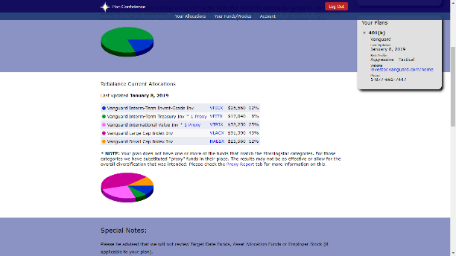



* Asset Allocation Models tailored to your employer’s investment options.
* Monthly updates on how to allocate your plan dollars
* Ability to review all risk tolerance models, which can be changed at any time. (Aggressive, Moderate & Conservative, etc)
* We offer “month-to-month” contracts that can be cancelled at any time, for any reason with the click of a mouse!

Ask your favorite investment adviser to set up your account in Plan Confidence!

If they cannot, have them contact Plan Confidence immediately so they can sign up and help you ASAP!

[*www.PlanConfidence.com*](http://www.PlanConfidence.com) *0r your customized URL:* to explore the service further.

**000-000-0000**